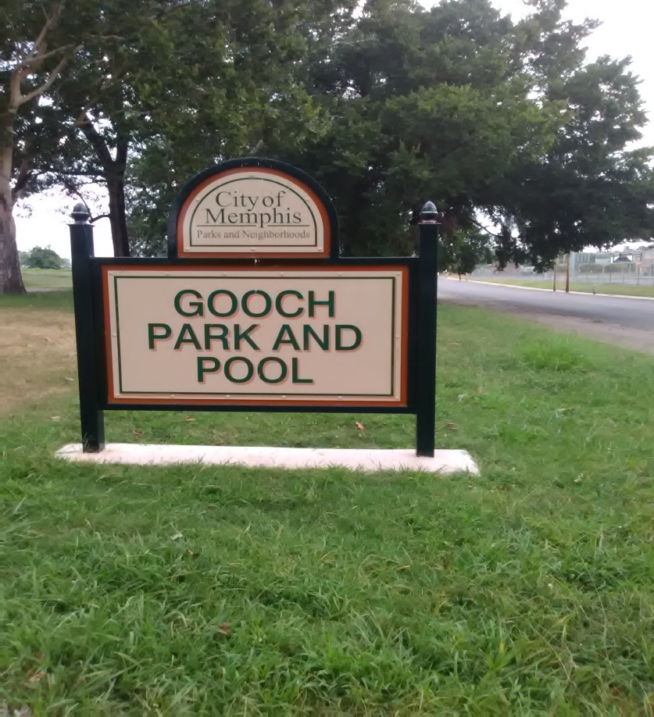
HUG PARK FRIENDS 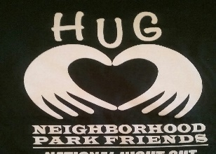 North Memphis, TN  Residents in Hollywood Hyde Park Springdale improve their parks and opens spaces using the ADOPT-A-PARK Program, Memphis City Beautiful |  |  |  | FEBRUARY | 2021 | Issue #2
In this issue
News from HUG Parks
Memphis City Beautiful promotes “Paint the City Red Campaign.”
Gooch Park Art Wall Mural Project
Jammond Bullock commissioned to paint art mural on the wall of the pool house. Memphis Park Services Outreach Coordinator cites reasons for delay.
CTC, the backbone agency for HUG PARK FRIENDS for SPARCC
North Memphis Voice schedules community meetings: March 12 and March 16, 2021.
News from HUG Parks  By Jo Ann Street, President/Editor |  | 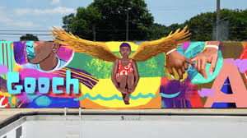  Gooch Park Art Wall Mural Project: Urban Arts Commission (uacmem.org) is thrilled to announce that UAC’s Neighborhood Art Initiative, the HUG PARK FRIENDS and Artist Jammond Bullock @alivepaint are creating a new mural for Gooch Park and Pool at 1974 Hunter Avenue, Memphis, TN 38108. This project was generously funded from the Assisi Foundation, Memphis.
Jammond Bullock Artist
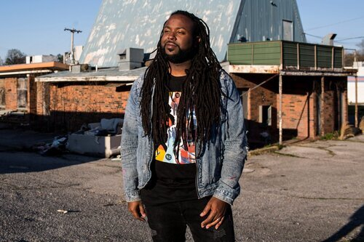

During the inception of this design, Jammond wanted to illustrate something fun to look at, but also was interested in reflecting on some of the historical details as well. The cyclist in the design represents an African American cycling club gathered at Gooch Park. In the lead of the bike race is the first African American to cross the color barrier in sports. He was Marshall Major Taylor. Let’s pray for his continued health and success!

 |  | HOLLYWOOD, UNIVERSITY AND GOOCH PARKS
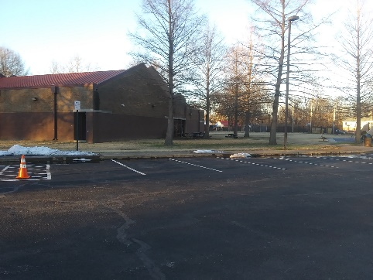  Hollywood Community Center!  Thank you for becoming a valued member of the HUG NEIGHBORHOOD, in Hollywood where parks and open spaces are great.  Thanks to Raquel Reed, the director, her staff and the City of Memphis Parks and Neighborhoods we have a place to meet and exchange ideas. Next month we will explore and feature another place you like, The Hollywood Library, Angela Adams, the director.  Memphis City Beautiful promotes “Paint the City Red Campaign”  RED ALERT! Memphis City Beautiful is hosting its Plant the Town RED campaign to rally citizens toward something positive and safe, March - May 2021.  We want all Memphians to UNITE and show their COMMUNITY PRIDE by cleaning up and planting RED flowers, trees and shrubs this spring!  Contact (901) 636-4410  CTC BECOMES THE BACKBONE AGENCY FOR HUG PARK FRIENDS FOR SPARCC  Center for Transforming Communities (“CTC”) has agreed to become the backbone agency for HUG PARK FRIENDS. Who is missing from meetings to discuss the needs and wants of the North Memphis community? IT’S YOU! Please contact Jeralyn Center for Transforming Communities @ jeralyn@ctcmidsouth.org to be added to the list of attendees. I hope you will join us in making North Memphis Voice a welcomed friend in Memphis. |  | Welcome New Members  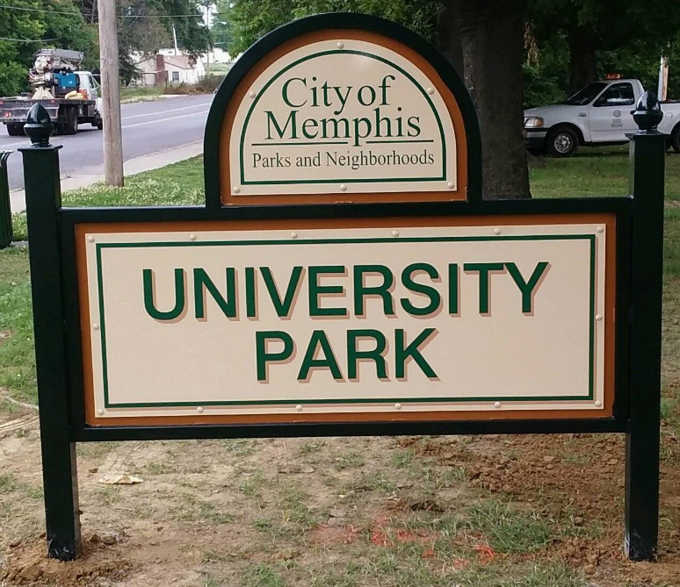  We would like to thank our project steering community for the art project “Gooch Park Wall Mural.” They are Adrienne Pakis-Gillon, Beth Bazar and Matthew Becker, Buckman International, Barbra Miller, Rhonnie Brewer, Brett Hanover, Urban Art Commission, Anna Carothers, Kendrick Simpson,, Mary Wilder, VECA, Syd Lerner, Greenline and Cyndy Grivich, Memphis City Beautiful. If you too would like to join with us, like us on Facebook and go to our website at www.hugparkfriends.org
Let’s talk about HUG “U” - University Park. This park with its amenities is adjacent to KIPP Collegiate. KIPP has an award winning baseball team led by Coach T. We are so fortunate to have them in our community. The plans for resurfacing the tennis courts by Memphis Parks is set to begin in the Spring, which is soon approaching. HUG PARK FRIENDS will engage with Tennis Memphis and the City to move this plan forward in 2021. If you are interested in the Tennis Program at University Park, please go to our website and sign up for updates. Also, like us on Facebook.
We want you to continue to be safe in the parks because of COVID 19. Many of us have lost loved ones from this lung disease that causes that has threatened the lives of our loved ones. Our hearts and HuGs go out to families everywhere. So, please be careful, but focus on what we can do in our parks. We can take walks, go for runs; and, ride our bikes. Looking for ways to be active, see our partner Shelby 4-H on Facebook. HUG Parks 4-H enjoys this.
Playground Leader 🌳🌼⛹️‍♀️
http://u.rfer.us/MEMPHISTNtYV2YL

Playground Coordinator🌳🌼⛹️‍♂️⛹🏽‍♂️🤸🏻‍♀️
http://u.rfer.us/MEMPHISTN1mO2YM

Rec Leader ⚽️🏀🎾🏐⛳️
http://u.rfer.us/MEMPHISTNN5v2YK
http://u.rfer.us/MEMPHISTN5et2YP

Life Guard 🏊🏾‍♀️🏊🏼‍♂️
http://u.rfer.us/MEMPHISTNHGe2YJ

Pool Manager 🆕
http://u.rfer.us/MEMPHISTNnRm2YI

Aquatic Attendant
http://u.rfer.us/MEMPHISTNEXx2YN

Meal Preparer
http://u.rfer.us/MEMPHISTN7se2YO

Mower Operator 🌱🌾
Golf Attendant 🏌️‍♀️🏌️‍♂️ http://u.rfer.us/MEMPHISTNesx2YH

